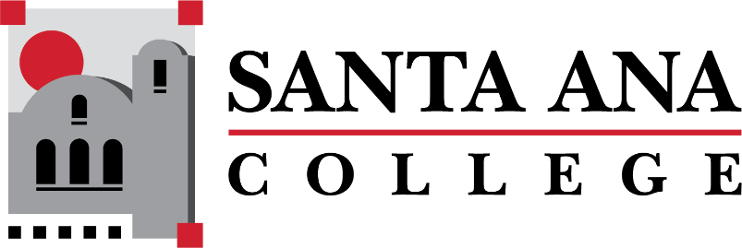

Dual Enrollment Workgroup Minutes
Tuesday, December 15, 2022 2:00-3:00pm., Hybrid
S-215 & Zoom

- Information sharing with high school partners – Matthew Valerius
  - Matthew Valerius – New Associate Dean of Career Education Workforce Development and Dual Enrollment
- Faculty onboarding and information sharing – Matthew Valerius
  - Amberly Chamberlain shared current onboarding process for DuE Faculty: Dept Chairs reach out to the HS faculty to get syllabus, and provide them with WebAdvisor username.
  - Admissions and Records provides add and drop details, how to clear rosters and submit grades.
  - Matthew Valerius recommends future onboarding processes include Zoom calls led by the DuE office which can share expectations, instructions on how to find rosters, etc.
    - Question came up regarding compensation for any training time period
    - Suggestions of providing various routes of access for information sharing would be ideal – Zoom, Webpages, Canvas Shells, Subtab for DuE Faculty on SAC DuE Website
    - Suggestion of creating a 1 pager high level items to share with new DuE Faculty to include: Roster, Drop/No-Show guidelines, key dates, when grades are due, key contacts.
    - Suggestion was made of providing DuE trainings during flex week.
    - Question was asked of what the process will be for departments that are not currently DuE like History & Law- Process TBD.
    - There are concerns on the Faculty Handbook that should be clarified before creating a new handbook
    - Matthew Valerius mentioned he would like current handbook updated to be a starting point to share out for Spring 2023
- Course request process & SAC course deadlines (need for annual calendar) – Matthew Valerius
- Limiting changes to dual enrollment course rosters – Matthew Valerius
  - Process to include confirming rosters early and ensure timelines are being followed.
  - Teams Site- Tabs by division of courses, course deadlines, course requests.
- Bookstore Costs Discussion – Basti Lopez
  - Spring 2023 Updates – Looking for competitive book rates for DuE sections – Possible OER/ZTC.

Upcoming Meetings:
Save the Dates: DuE Retreats
- January 25, 2023 | 9:00am-12:00pm | JSC 219
- May 12, 2023 | 9:00am-12:00pm | JSC 219

